Synthesising Creativity: Systems to support interactive human processes for aesthetic product design

Modestos Stavrakis  modestos@aegean.gr | Thomas Spyrou  tsp@aegean.gr | John Darzentas  idarz@aegean.gr
University of the Aegean
Department of Product and Systems Design Engineering
Ermoupolis, Syros,
GR 84110, Greece

Abstract

Current technology systems, focusing in product design, do not provide a complete creative environment. This paper proposes the ‘fusion’ of artificial agents and human designers in a synthetic environment for aesthetic product design. Computational models alone cannot fulfil the cycle of aesthetic product design because they are unable to evaluate variables related to aesthetic features of products/artefacts intended for humans. To overcome this limitation this paper proposes a system based on agents that act as a society and interact with designers in order to support their creative processes for aesthetic product design.

Introduction

Human creativity is both special and ordinary. Humans are beings known for their creativity their ability to make art and literature, and to produce their own artificial tools and environments (Smith, 1997). However, at present, tools do not support creativity in any significant way.“Creative design requires deeper rather than shallow analysis and the current CAD techniques are not necessarily promoting this” (Lawson, 1999). The aim of this research is to identify requirements of computer support for interactive creative work by exploring the potential of new technology for aesthetic product design. Fundamental to this work is an understanding of how creativity, in product designing, works. The objective is to enable designers to produce innovative artefacts and study the implications of future technologies in aesthetic design. In addition, a key area is to understand the requirements for support structures for creative practitioners.
Based on human centred designs that collaborate with new media, this research builds upon existing art forms and art practice to eventually lead to entirely new ways of working/designing, and very probably new genres of artefacts, that could be mostly digital.
There are great opportunities to expand the range of tools that support and amplify the creative processes. Current research looks at this by studying human creative actions/behaviour and identifies methods that can aid designers in producing novelty for product/artefact aesthetic design, by interacting with intelligent computational systems that act as the new creative medium.
The research described here is focusing on a society of artificial agents that observe human processes, explore the human-computer interactions that support the emergence of ideas and evaluate the capacity of novelty of the artefact; therefore, the evolution of the design.

This paper presents an approach to creating a support environment for creativity, which is based on a community of adaptive agents that act as a mechanism to motivate users and support them during the conceptual phase of the creative process of aesthetic product design, by observing their actions\behaviour and suggesting methods that extend or move the state space of potential designs. Furthermore the system’s architecture will support the sharing of knowledge, among the society of heterogeneous designers, and assist designers’ creativity to emerge, in a manner similar to that occurring in group design teams (Edmonds, 1994)(Candy, 2000-2002)(Mamykina, 2002).

Models of Creativity

Creativity is a term inadequately defined, although there are many definitions in psychological literature (Taylor, 1988). The fuzziness of the word is related to the variety of the domains to which the meaning of creativity refers.
There are many theoretical models proposed and many empirical studies introduced in order to provide detailed accounts of the processes involved in creativity (Saunders, 2002). Finally there is an attempt to merge all previous research by unified models that classify creativity in terms of theoretical frameworks. Boden outlines two different interpretations:
- P-creativity or personal/psychological creativity, where concepts or ideas are novel to the designer’s mind from which the initial idea emerged
- H-creativity or historical creativity, where the idea is truly novel and have never been thought before; (Boden, 1990).
An important extension to Boden’s model is the S-creativity model introduced by Gero:
- S-creativity or situated creativity occurs in designing when the design contains ideas which were not expected to be in the design when the design was commenced. Thus the design contains ideas that are not necessarily novel in any absolute sense or novel to the designer but that are novel in that particular design situation (Suwa, M., Gero, J. S. and Purcell, T., 2000).
In addition to these models (Shneiderman, 2000), identifies the human creative processes, when interacting with computer systems, and distinguishes four phases of action: Collect, Relate, Create, and Donate. These are similar to the characterizations of (Couger, 1996): Preparation, Incubation, Illumination and Verification.
Based on these four processes Shneiderman introduces eight activities of human-computer interaction: Searching and browsing digital libraries, Consulting with peers and mentors, Visualizing data and processes, Thinking by free associations, Exploring solutions- What if tools, Composing artefacts and performances, Reviewing and replaying session histories and Disseminating results.
Finally, for creativity taking place in synthetic environments the research of Edmonds (Edmonds, 1999) considers that designer ‘manipulates’ his imaginative artefact in three different realities: Imagined Reality, Virtual Reality and Actual Reality.
Aesthetic design is probably the one of the most important tasks in creative design when introducing innovative products, and in many cases, novel. Existing design tools and systems tend to ignore this aspect of product design because of its complexity; it involves the aspect of creativity, mentioned earlier. In defining product design by taking into account situatedness, it can be treated in terms of variables conveniently categorised to define structure, behaviour and function (Gero, 1994).

Agents that Support Human Creativity

Design is a complex process closely related to creativity and creativity itself a process closely related to human processes still unknown. It is also believed that the interaction between designers and the environment, through the support of computational models, strongly supports their creative processes.
An important consideration when designing support systems is the introduction of adaptive (virtual) autonomous agents. Autonomous adaptive agents are dynamic entities and are designed to autonomously decide when to be re-designed to adapt to their environment. Their functionality can evolve during their lifetime (Brazier, 2002).
Fundamental arguments to creativity and agents are analogy and situatedness.
- Analogy is the novel combination of familiar ideas (Boden 1994). Analogy-based models, implemented in software, are usually seen as communities of agents.
- Additional to analogy is situatedness a notion recently introduced to the agent model by (Gero, 2002). Situatedness means that concepts related to designing change according to what designers see, which itself is a function of what they have done. This can be modelled as the interaction of three worlds: external, interpreted and expected world that exists inside interpreted world (see Figure 1).

Figure 1: Situatedness model (Gero, 1994)

The introduction of agents that support human creativity have to ensure that the proposed computational models interact with designers and help them by suggesting, identifying and even evaluating differences between familiar ideas and novel ones (Boden, 1994) and in this case by considering the variables of the designed artefact. At a higher level this relates to the ability of these agents to decode and adapt the symbols that exist to their external world.
Finally, this community of agents must have the ability to observe human actions and behaviour, while the humans are interacting with the system, and performing operations to stimulate designers’ creativity. This is the user personalisation that adaptive agents often are used for and in extension the generation of a perspective view of the behaviour of a community of designers. Agents within a semantic network not only effect associations but also trace the associative pathways involved, which in itself might prompt the user to new insights (Boden, 1994).

Concept Architecture

In order to make more concrete this line of research, this paper introduces an architecture (see Figure 2) that unifies previous research and aims to support the human in aesthetic product design. The basic components are: the Human/Designer, the agents society, the Virtual Design Tool and Digital Libraries.
Humans as a creative individuals can be characterised by situatedness. They have internal and external world and in addition physical representation. Built in their inner world, in terms of sensory experiences, perceptions and concepts, is their interpreted world. With imagined actions, an expected world is produced which is identical to their imagined reality (focusing). Their external world is the world that is composed of representations outside them, everything they are interacting with.
To begin with, the humans construct an initial idea regarding their expectations in their imagined reality; this is the first step in their constructive memory. The next step is to interact with the system (combined VR/CAD) in order to produce an early representation of the artefact. This interactive process is observed by the agents’ society. When agents, through interpretation of their external world (i.e.human actions in VR and actual behaviour, search in digital libraries), identify symbolic language known to them, (built into their own capacity), they plan their expected world and finally they perform appropriate actions to support human aesthetic decisions. Continuous cycle of this procedure causes situatedness for the evolution of the aesthetic design of the product (different values in every cycle for product structure, behaviour and function). Because humans and agents collaborate in this creative environment there is a possibility of novel conclusions, although the evaluation is mostly dependent on human judgments.
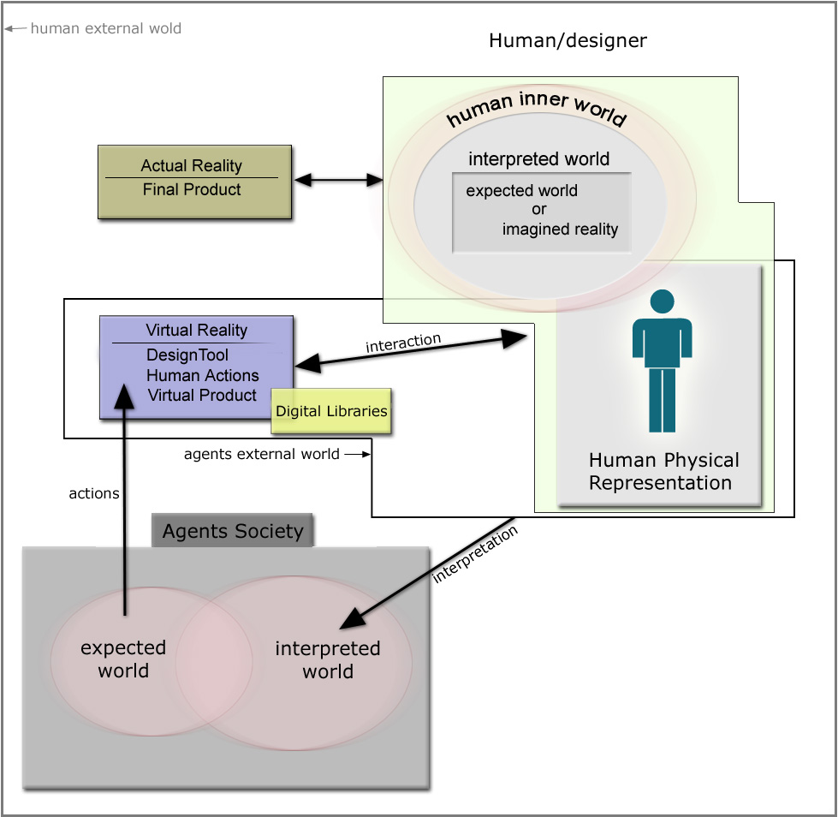
Figure 2: Concept Architecture.

Conclusion and future work

This paper identifies an approach for a system that analyses concepts that structure human creative perception which lead to the phenomenon of the emergence of novel ideas in a creative environment of multi-agent system that study human behaviour during progression towards novelty for aesthetic product design. Moreover, they construct a personal profile for each user/designer and support sharing of knowledge in the design domain. Future work includes a detailed description of the role of the agents that exist in the agent society and further evaluation of the endurance of the model in time.

References
Boden, M (1990). The creative mind, myths and mechanisms, London: Abacus.
Boden, M (1994). Agents and creativity, Communications of the ACM, 37(7), 117-121.
Brazier, F.M.T., Wijngaards, N.J.E., (2002). Designing Creativity. Proceedings of the Learning and Creativity in Design workshop at AID'02.
Candy, L. (2000). Dimensions of Art-Technology Partnerships in Collaborative Creativity, Collective Creativity Workshop, Nara Institute of Science and Technology.
Candy, L., Edmonds, E.A. (2002). Modeling co-creativity in art and technology. In Proceedings of the 4th International Conference on Creativity and Cognition, ACM. 134- 141.
Mamykina, L. Candy, L. and Edmonds, E.A. (2002). Collaborative Creativity. Communications of the ACM Special Section on Creativity and Interface, 45(10), 96-99.
Edmonds, E. A., Candy, L., Jones, R., & Soufi, B. (1994). Support for collaborative design: Agents and emergence. Communications of the ACM, 37(7) 41-47.
Edmonds, E. A., Candy, L., (1999) Computation, Interaction and Imagination: Into Virtual Space and Back to Reality. Computational Models of Creative Design IV, 19-31.
Gero, J. S. (1994). Towards a model of exploration in computer-aided design, in J. S. Gero and E. Tyugu (eds) (1994). Formal Design Methods for CAD, 315-336
Gero, J. S. (1996). Creativity emergence and evolution in design: concepts and framework. Knowledge-Based Systems, 9(7), 435-448.
Gero, J. S. (2000). Computational models of innovative and creative design processes. Technological Forecasting and Social Change, 64(2-3), 183-196.
Gero, J. S. (2002). Computational models of creative designing based on situated cognition. Creativity and Cognition 4, Loughborough University (to appear).
Lawson, B. (1999). ‘Fake’ and ‘Real Creativity using Computer Aided Design: Some Lessons from Herman Hertzberger. In Proceedings Creativity & Cognition 9, ACM, 174-180.
Shneiderman, B. (2000) Creating Creativity: User Interfaces for Supporting Innovation. ACM Transactions on Computer-Human Interaction, 7(1), 114-138.
Smith, S. M. (1997). The Machinery of Creative Thinking. Retrieved January, 2003, from
http://www.winstonbrill.com/bril001/html/article_index/articles/251-300/article290_body.html
Suwa, M., Gero, J. S. and Purcell, T. (2000). Unexpected discoveries and s-inventions of design requirements: Important vehicles for a design process, Design Studies 21(6), 539-567.
Taylor, C. W. (1988). Various approaches to and definitions of creativity. In Sternberg, R. J. (Ed.). The nature of creativity: Contemporary psychological perspectives (pp. 99-121). Cambridge: Cambridge University Press.

