Smart Packaging: New Communications Concepts and Models
Spyridon Nomikos
Department of Product and Systems Design Engineering, University of the Aegean, Hermoupolis 84100,
Syros, Greece.
nomic@aegean.gr

Keywords
Conventional packaging, smart packaging, cross-media, communications concepts and models.

Abstract
New technologies are beginning to replace traditional packaging printing, in terms of integrating digital information onto physical, material-based packaging, and are characterized by the wide application of electronic processing environments and the processing of both printed and electronic media.
Packaging thereby forms the centre of an intensive research field into new technologies that integrate digital data on a traditional package. Various applications are being implemented and pilot tests are being performed, fuelled by developments in electronics technology, materials and processes, which are characterized as being “intelligent” or “smart”. The new intelligent packaging incorporates microchips, antennas and new materials such as thermochromic inks and various indicators that track changes and provide real-time responses and wireless communication capabilities.
This paper explores the new packaging concepts, and also examines the new communication models in the smart packaging sector.
5. A New Conceptual Model for Smart Packaging

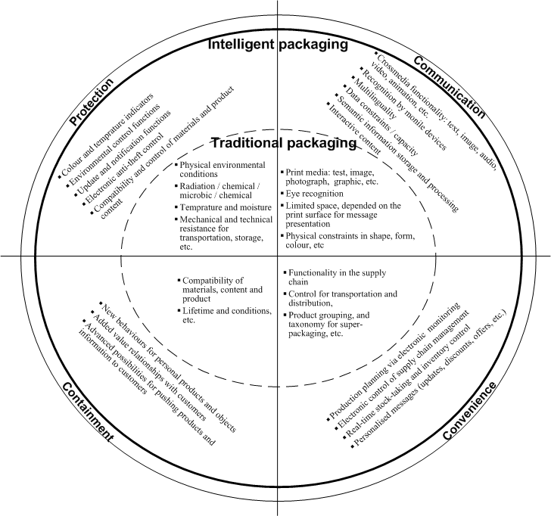

7. References
(Abbot DA-1989) Abbott DA. Packaging Perspectives. Kendall/Hunt,Dubuque, IA, 1989.
(Hine T-1997), The total Package-ISBN780316 365468-Back Bay Books
(Kit L.Yam et.al.-2005), KIT L.YAM,PAUL T.TAKHISTOV,JOSEPH MILTZ, Journal of Food Packaging,Vol.70,Nr.1,2005.
(Nomikos et al-2005), Exploring cross-media concepts for future packaging – Challenges for the printing industry/
Spyridon Nomikos, Anastasios E. Politis, Jenny Darzentas, Thomas Spyrou, John Darzentas,Proceedings,32nd international Conf.Iarigai.4-7 - Sept 2005, Digitalisation and Print Media ,p.p.317-319.
(Raghu Das-2004) Raghu Das 2004, Peter Harrop ,Glyn Holland , The A to Z of printed and disposable Electronic, IDTechEx, Cambridge, UK.
(MIT Auto-ID Labs-2004), MIT Auto-Id Labs,6-8 April 2004,Presentations
(IDTechEx-2005) ID Tech EX , Presentations 19-20/4/2005 Cambridge.[Smart Packaging, Conference]
(Kipphan 2001), Kipphan H., (2001), Handbook of Print Media, Springer Verlag, Berlin.
(GATF-2000), GATF, 2000 .Technology Trends for the New Millennium, GATF 2000 technology forecast, USA.
Gen-Daniel Lt, Brown G., (2002) Smart Packaging Journal July/August 2002, IDTechEx, Vol.1, Issue 1 pp.3-5.
(Politis, A.,-2004) , Politis, A., -2004. Human capital development and competence structures in changing media production environments” Doctoral Thesis, Royal Institute of Technology, Stockholm Sweden.
(Politis, A.-2002). Politis, A. (2002) The influence of the human factors on the performance of media enterprise – case studies on cross -media publishing in Greek media enterprises», Media Firms: Structures, Operations and Performance, pp 205-224, Lawrence Erlbaum Associates Publishers, Mahwah, New Jersey USA.
(Baumann, R. & Weiss, R.,-2005) Industrial Printing Opportunities for Polymer Electronics”, MAN Roland Druckmaschinen AG, in the Printed Electronics Europe conf., Cambridge, UK, (IDTechEx)]
(John Cooney-2003).John Cooney-Barry Winkless, University, College Cork, Ireland.(TRIZ methodologies and develop, next generation of food packaging concept).
(Stewart B.-1996) Stewart B.,Packaging Design Strategy-Pira International-(ISBN 1 85802 064 6 )Edition 1994-1995 twice-1996./ www.pira.co.uk.
(Peter Harrop -2005).An Introduction to Smart Packaging. Cambridge IDTechEx 19-20/April/2005.
(RFID Privacy).The Microsoft Perspective ( Submitted to the Federal Trade Commission)as a follow-on to the Workshop on RFID: Applications and Implications for Consumers, June 21, 2004 /
(Thomas Lindner] Printed Electronics Cambridge, UK, April 25 2005–HP- Technology beyond, Ink on Paper Hewlett Packard Co].
(Taoukis PS,Labuza TP.2003).Time-temperature indicators(TTIs).In:Ahvenainnen R,editor.Novel food packaging techniques.Cambridge U.K.:Woodhead Publishing Limited.p 103-126.
(PHT Product Suite.www.phtcorp.com).The PHT Product Suite.www.phtcorp.com/Solutions/product_suite.asp
(Intelligent Inks-2005).Conductive Inks in Packaging Applications, Vienna Austria 8-9 November 2005
(Electronic Smart Packaging Reports-2005/a). IDTech, Raghu Das.,pp 10-18,Cambridge 2005.
(G.A.S.P.I.A.N.-2004)-Tracking everything, everywhere, Katherine Albrecht-2004.www.gaspian.com
(MITs Auto-ID Center); Article represented / cooperation, in G.A.S.P.I.A.N.[Consumers Against Supermarket Privacy Invasion and Numbering].
(J.Lindsay,et.al -2004) Retail RFID Systems without Smart Selves-J.Lindsay,et.al.-.Publ.23/Dec./2003-Nov.7,2003.
(www.aimglobal.org). The Association for Automatic Identification and Mobility.(www.aimglobal.org).
(Cypak AB/2005),Cypak AB /2005.Smart, secure and connected solutions for time-tagged data capturing. Marie Wall, VP Business Development.IDTech-Printed Electronics.19-20/2005-present. Cypak AB
(Electronic Smart Packaging Reports-2005/b). Electronic Smart Packaging. Reports. . IDTech, Raghu Das.,pp 7-8,Cambridge 19-20/April/2005.
(www.future-store.org).METRO-Future Store.(www.future-store.org).
(www.rfid-weblog.com).
(Trinetra: Assistive Technologies for the Blind-2006),Patrick E. Lanigan, Aaron M. Paulos-Andrew W. Williams, Priya Narasimhan-May 1, 2006-Carnegie Mellon University

