Prototype System for Virtual Reality Simulation and Training:
Initial Implementation for Large Printing Units

V. Charissis¹, S. Nomikos², M. Patera¹
1. University of Glasgow / Glasgow School of Art, Digital Design Studio, Glasgow, UK
2. University of Aegean, Department of Product and Systems Design, Syros, Greece

Keywords: Simulation, Training, VR, Large Printing Units, HMI

This paper presents an enquiry into the suitability of Virtual Reality (VR) technology as the principal training method for a large printing unit. Recent studies have suggested that VR training methods can provide beneficial outcomes by decreasing the learning curve [1]. Modern printing machines for larger units require special training prior to operation as they combine high-end technology with expensive components.
Usually the companies that build the machinery provide training seminars for their client’s staff, which often involves travelling and accommodation costs for either the trainees or the trainer. Also, it is evidently very costly to run in-house training sessions as most printing stations have been preset for specific jobs (e.g. layout, number of copies, folding, cutting, etc.) and precious production time can be lost during resetting.
Furthermore, in certain cases, the units utilised by a company may have been ordered and customised according to the company’s printing needs, therefore the “default” training on a specific unit can serve as a generic introduction that conveys only the basic level of knowledge and not what is immediately required.
The purpose of this research is to initially identify the appropriate hardware and software requirements for accurate representation of any given customised printing unit for minimising the cost and time [2] of such training sessions. Therefore, we designed and implemented a novel training system for large printing units using a prototype VR environment and portable hardware. In this end, a Human Machine Interface (HMI) has been designed in conjunction with activity-centred rationale in order to facilitate the main training stages for operation of large printing equipment [3].
For evaluating the proposed method we have visualised an accurate 3D model of a Heidelberg Sunday 4000 in a VR environment illustrated in Figure 1. The printing unit has been projected in a holographic evaluation room (SCI-FI Lab) consisting of a large rear-projection screen (1.8m width by 1.2m height) using an active stereo CRT projector maintaining a steady frame rate between 40 and 60Hz depicted in Figure 2. The user wears wireless stereo glasses that separate the images for the left/right eye respectively. The system can also identify the user’s position in space with tracking devises placed inside the room. A simplistic and comprehensible interface allows the user to manipulate through views, select and operate the 3D machine model with the use of a joystick [4]. Although we had previously experimented with the vibro-tactile gloves (immersion cyber-glove), our choice of haptic feedback focused on the joystick as it is
considered to be an easier and more acceptable mode of interaction [5].
For training purposes, the printing machine’s components have been separated into the main divisions of the printing process in order to simplify the procedure. By reducing the number of projected components it is feasible to increase the mechanical engineering detail of the unit, the projected image quality as well as the complexity of the interface. A series of tasks (pre-print, print and post-print) have been implemented for the initial evaluation methodology of the system. Nevertheless, the simulation has highlighted some potential problems stemming from the non-specialised nature of the VR visualisation system, which could be dealt with by adding haptic and auditory cues [5].
In the future we aim to incorporate these additional cues in order to achieve a highly immersive experience for the user and thus assist in reducing the time and cost of real-life training. We further plan to compare user’s learning performance in the VR environment as opposed to the real-life training. Finally, it is our intention to explore and simulate and evaluate additional training scenarios and HMI components.

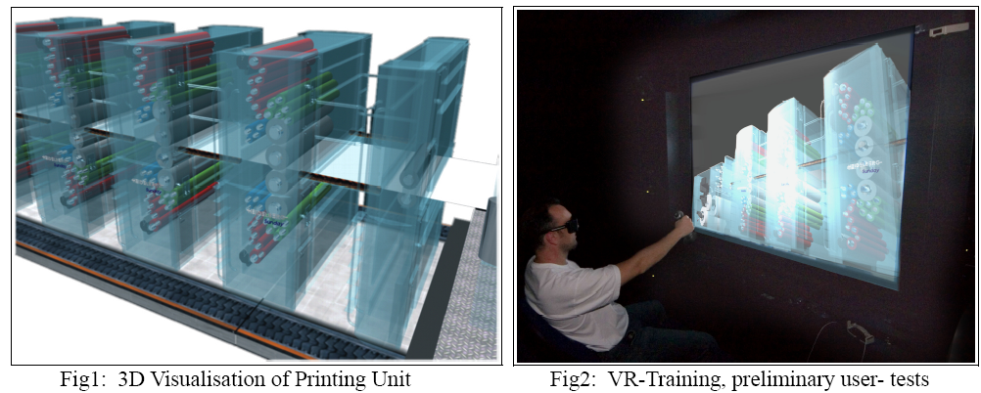

References:
[1] Sang-Hack, Jung & Bajcsy, R. (2006) Learning Physical Activities in Immersive Virtual Environments. In: IEEE
Proceedings of the International Conference on Computer Vision Systems, ICVS '06, St. Johns University,
Manhattan, New York City, USA
[2] Anderson, P., Kenny, T. & Ibrahim, S. (2002) The role of emerging visualisation technologies in delivering
competitive market advantage. In: Proceedings of the 2nd International Conference on Total Vehicle Technology,
Institute of Mechanical Engineers, University of Sussex, Brighton, UK.
[3] Gay, G. & Hembrooke, H. (2004) Activity-Centered Design: An Ecological Approach to Designing Smart tools
and Usable Systems. The MIT Press, Massachusetts Institute of Technology, Cambridge, Massachusetts, USA.
[4] Kuang, A.B., Payandeh, S., Bin Zheng, Henigman, F. & MacKenzie, C.L. (2004) Assembling virtual fixtures for
guidance in training environments. In: IEEE Proceedings of the 12th International Symposium on Haptic Interfaces
for Virtual Environment and Teleoperator Systems, HAPTICS '04, Chicago, IL, USA.
[5] Hara, M., Asada, C., Higuchi, T. & Yabuta, T. (2004) Perceptual Illusion in Virtual Reality using Haptic Interface.
In: IEEE Proceedings of IEEVRSJ International Conference on Intelligent Robots and Systems, September 28 -October 2, Sendai, Japan.

