PUBLISHING SYSTEMS and PRINTED ELECTRONICS. Social approaches by printing substrates with optical and digital content.

Nomikos Spyridon / TEI of Athens / Graphic Arts Technology / Greece

nomic@aegean.gr

ABSTRACT

Publishing systems but also crossmedia, have proved their functionality in the process of announcement and transmission of information, in the printed and electronic communication. Recently, there has been a lot of scientific announcements on intelligent packing and printed electronics, that create a new circle of relations of behavior, the intelligent prints. These intelligent prints, (e.g. intelligent packing), it is result of relation between the conventional and electronic technology, based on the new conductive materials. A basic constitutive element of intelligent systems in printed works is the collaboration of conventional printed media with the RFID system. It is known that the elements of printed communication have been shaped, through system of publications and contain characteristic elements, e.g. the form, the drawing, the style, the size, the color and other formal elements, which have shaped social behavior of persons. Thus from this angle of approach, we propose and present the given elements, that will influence the new social behavior, which will result from the relation of conventional printed work with the digital content of RFID system, [Nomikos et al /2005]. In our work, we present the roles and the sectors, which will be influenced from the new situation of designing of electronic printed works, which will have printing substrates with optical message and digital content.
Keywords
Publishing systems, Crossmedia, Electronic-Smart printed work, RFID system, Social - Behavior.
BACKGROUND
Definition of print media – Conventional Publishing and publishing products
As a “printed work” we define the result of the process for the publicizing of the content of a message, with publication, on substrates of material, where ordered information exists, (text/ picture/ drawing) and they render meaning, aiming at the comprehension of content, [Nomikos S.2006]. We all know printed products, that is to say, books, periodicals, newspapers, technical handbooks, notes, brochures, cards, printed circuits, bills, obligations, bottle labels, bank notes, traffic signs, printed boxes, printed inscriptions, tickets, and many formed articles, e.g. packing, that we meet in supermarkets, in the market, in various forms of printed substrates. These printed products are the result of conventional and digital printing,[Ivana Ziljak,2003],-publication, through publishing process.
Crossmedia and Applications
Politis .A. 2002 suggest that, the term cross-media, are the common processing of data, that can then be directed to both printed and electronic media of communication. Dreyer determines another definition for cross-media. He agrees that publication takes place once but follows the flow of work in multiple means, but he also remarks that this happens only because the process is followed through the XML programming language. Moreover, a publication in format JDF is followed, where are attributed new possibilities for production so much in forms, as much as in electronic means, [Dreyer, 2001]. Use of the Cross-Media technology is made in the following cases: In publications in more from one means of announcement-projection (periodicals, reports etc.). In on-demand publications, (Parliament documents, results, juridical decisions). In large volumes of information (dictionaries, telephone lists), in documents with large frequency of changes of content, as well as in personal publications (personalization) of large or small volume and others. In publications where is required [info-communications] and search in web pages, via interconnection (Link).
PUBLISHING SYSTEM
Publishing activity exists in various forms from ancient’s years until today. This form of graphic communication, as publishing activity, it has changed so much as for the structure, what as for the methods. Substantially however remains what was always, the creative and effective communication, until today, [Handbook of editor, 1998]. Essential condition for the announcement of content of message is the publishing activity, which becomes with two ways, conventional the electronic management-publication.
PUBLISHING BEHAVIOR AND TECHNOLOGICAL CHANGES
Because of the progress and the newly formed state of things, publishing mechanisms have changed through the institutions and the new activities of libraries - rights and processes & new capabilities of the Internet. Thus, through the increased process of publishing systems we record the process, through which, thought or even notions are contained, in an author’s work, through the book form (printed work), or a file on the Internet, or in a storage medium (CDs-DVD, etc.) to be read by a technical means (screen).
New actions
Entertainment Industry
Communication – Information Technology companies
Consumer Electronics Companies
Traditional visual communication media
Newspapers/magazines
Books
Television/Cinema
Radio
Recorded Music
Customers
Companies,
Consumers,
Advertisers,
Organizations
New competitors
- Electronic Publications
- Electronic databases
- Multimedia Applications
- Internet

Suppliers

Paper
Electronic Products
Materials - Consumables

[Politis,Α.2004-a]
Printed Electronics – Smart Packaging. Indicators -(ΤΤΙ-ΤΤΒ)(Τime Thermochromic Indicators-Time Thermochromic Biosensors).
The frame and the determination of indicators ([TTI]-[TTB]), is determined through optical perception and does not contain information content. However, the system of RFID, is a informational communication system with content. RFID is a system of self-identification and identification. It has a lot of possibilities and applications. It can make separation of information, as well as manage the information. It has potential of management and memory and also, it is capable of communicating through compatible frequencies with the corresponding product, with the registers, or the readers, on printed material, packing etc, [MIT, Auto-Id Labs]. The systems are constituted by basic parts, that is, the antenna and the chip. The antenna is printed and constitutes part of the publishing process. Thus the antenna is a part of printing part, because it is (for safety reasons) printed out on the rear side, namely on internal one of the printed substrates(aspect). In the printing of indicators ([TTI]-[TTB]), there exists a different approach because the printing should be made on the exterior surface and on a well visible point. During the definition of [TTI]-[TTB], in a graphic presentation, we separate the frame because of the fact that there are no data and information with content, but it functions only as optical perception, through the geometric surface (of small dimension), which only informs and warns about the situation of the product in the dimensions, of packing.
Thus through this approach, intervenes the place of semiotics in the graphic representations, as conceptual and aesthetic presence, through the forms of form with the pointing out in question.
We point out, that S.P. has a communicational character, however in the sector of application of Indicators ([TTI]), ([TTB]), there exists note - warning, namely, it has optical presence and the character of a particular message, [Nomikos et al, 2006].
FACTORS THAT WILL INFLUENCE THE SOCIETY THROUGH THE NEW STATE OF THINGS
With the advent of meta-requirements-effect in the newly shaped tendency of E.P. (Electronic Prints), we will mark the corresponding studies of Institutions in Projects /USA, but also of the E.U, where as a result the new befalling tendencies and behaviours in the printed-electronics industry appear. The Project of University of RIT/[Leslie Oak, 2003], records in the study, from the figures that they have collected, that in year 2020, electronic systems will have a 40% increase (in the share of communications), in comparison to paper, which will recede in percentage 20% from the year 2006.
Also, in the preliminary studies of [Nils Enlund/KTH-Mattsson Bertil/STFI-Robert Picard /KTH-Borje Alstrom /Den-Gulliksson], on the behavior in the social and cultural becoming of countries, for the new status in communication, [T2Fs Project, STFI, 2001], they depict the status of A. Social - demographic behaviors, B. Givens of choice in the communication media, C. Technology influences D. Economic factors, E. Givens of choice from advertisements, from communication media, where they drew up preliminary studies and pointed out social and technological, economic modification, in the influences from communication media. Thus, they conclude that the tendencies show a rise of electronic communication and also that there exist influences that will convert the social structure and other relations in the behaviours with the users.
An enterprise approach is made by the University of Cambridge, where it presents intelligent applications around the world with economic elements, where it determines the future for the new coming applications, [IDTechEx, Case Study, 2006]. Consequently, from the preceding, it is obvious, that printed-electronic products, will also have the corresponding influence and formation, both in the designing and the influences of relations of the social-philosophical and technological - economic status. This is depicted in the following sections, with criteria which are results of sectors that will have the corresponding pressure from the formation of electronic printed product.
PRODUCT DESIGN MODELS
Marianna Stokcholm (Stokholm, 2003) proposes a frame for the elements of the design of a product, aiming at the creation of a common acceptable model for the comprehension of the parameters of influence in design. According to this frame of design elements, a commonly accepted holistic tool has been created, which aims (via the philosophy) at the improvement of communication in the required applied practice. Such a model, at first level, necessarily includes the elements of aesthetics, existing capabilities of technology, the strategy, the environment, and as Aristotle states, the form of the material and the relation between cause and aim. At the second level, (the proposed models), refer to the result of production and use, in the sector of the individual and natural environment.
It is then comprehensible, that the cultural and business frame guides and constitutes the design basis of all industrial products.
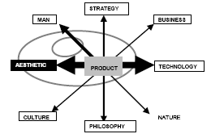
Elements related to Design based product, (Stokholm, 2003)

PARAMETERS & TECHNOLOGICAL CHARACTERISTICS IN THE FRAME OF ELECTRONIC PRINTS
- Determination - choice and classification of the antenna 2. Recording –specifications (of the printed product and information on its use) 3.Checking and classification of already existing antenna designs [TTI]-[TTB]-screen. 4. Electronic circuit (Indicator antenna-circuit-screen-battery, speaker-sound.)
NEW DEMANDS STEMMING FROM THE INTERACTION OF PRINTED ELECTRONICS
The design state in printed industrial communication exists today to and acts through the technology of crossmedia. As it was a presented in a previous report, it followed an evolutionary course with enough influences from the electronic technology of computers. The new, under formation, situation, is supported by the history of development of course in the real environment, (that is continuously shaped) and considers it as well-founded element in its development from Conventional to Printed Electronic Communication.With this possibility, the new situation determines the factors from which it will be constituted and will be shaped by the new behaviors. With the classification of characteristic data, we will create models and directives on the new form of double communication, that is to say, a frame for the Smart Printed-Electronic Communication. A New Model, (print-media with digital content), application on Packaging, (Smart Packaging),[Nomikos S.2006] 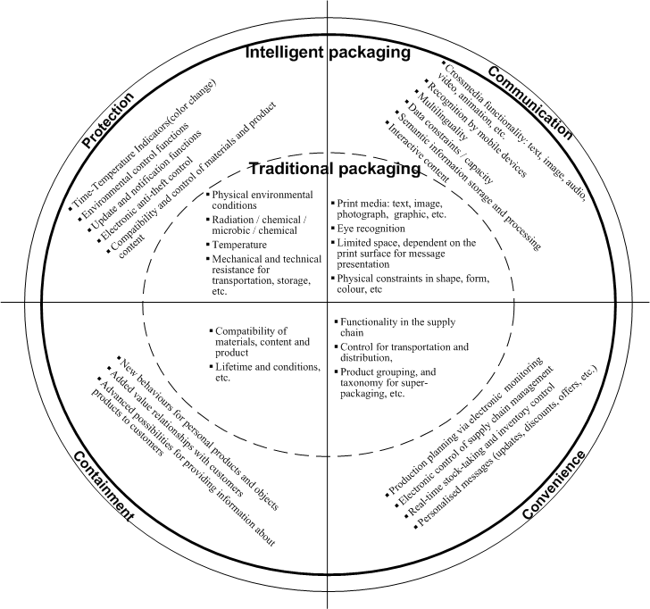

INFLUENCE PARAMETERS OF THE ELECTRONIC PRINT

1. CONTENT

The content of a book, the printed box of packing, the printed label and all printed substrates belong to the category of conventional (printed) products, that have until today static message. This is differentiated and is being developed in a new communication environment through the electronic printing and can contain dynamic message. [Nomikos S.et al. 2006]. As dynamic message has been defined the content of message, that can have animation but also be modified and be shaped at demand in dynamic means, in time duration, (text – animation – sound - video, etc), [Nils et al.2000], [Sabelstrom M.2001], [Neuman 1991], [Kleper M.2002]. The content of a printed book, the printed out box of packing, the printed out label and the all other static printed works, will be capable of changing their structural state but also the behavior in their presence, in the environment of optical communication. They will have the possibility of communicating through a RFID system in a wireless way and they can have possibilities according to the model, the possibilities of smart packing. The sectors that will be differentiated and will contain this transformation, were determined and analyzed in the frame of new Intelligent Printed Work [of packing] and are analyzed in Content, Communication, Protection, Usability.

ELECTRONIC SYSTEM – CIRCUIT - SCREEN

With the discovery and development-formation of polymer organic materials, new possibilities have emerged, from the properties which, until today, existed only in metals, for electrical, mechanical, electronic, chemical applications. One of the basic sectors of today’s revolution is the industrial printing electronics. The electronic system is being formed, regarding its role, into a new special role with circuits of production being autonomous or as a subsystem of the general integrated circuit into an end application, through the industrial printed communication of crossmedia, Graphic Arts. Thus, various applications have the capability, through printing methods, of functioning and rendering a message on a calculator screen, or as game console circuit, as an indications circuit or part of a electronic system (Motherboard), battery, wiring, antennas, sound signals, etc.

The RFID system (printed antenna and chip), together with the printed (electronic) battery, and wiring (electronic circuit system), can constitute a total “package” (RFID system-Monitor-Screen-Battery) of a system also regarding the content & electronic system in an intergraded set, with static and dynamic as well as a self-identifying network system. That is to say, electronic information can also exist in the physical static book, through the RFID system, [Nomikos et al. 2006].

SEMIOTICS

Graphic Design of communication products

How can crossmedia communication coexist with the optical perception of the indicator in the physical product? What will the indicator symbolize with the green or orange colour on various packing? How will the statement of price coexist with the embedded-printed screen on the surface of the product? [Kallenbach J /2004],. The research sector allocates the coexistence of the designing of the product with the publishing system in an idiomorphic behavioral environment, on the one side, between the design of the form and the of shape of an electronic printed material, but also, on the other side, of the publishing of the contained message (crossmedia) in digital form, which is presented-recognized and transmitted through a computer or to a conventional system e.g. mobile phone, PDA, e-paper etc., which exist in the same physical packaging product. A parameter that influences the creative-crossmedia publishing production-presentation of the various schematic graphic forms, on surfaces through printing (colour surface and form of shape) is also the aesthetic projection of TTI/TTB. Regarding TTI-TTB indicators, a different design approach will appear, concerning the product’s promotion, which is the aesthetic presentation of the product, with a positive or negative disposal of the visual presentation of the product form. This will be a particularly sensible sector in packages for cosmetics and food packages where competition in promotion exists (that is to say, on indicators in the substrate which will indicate the duration of storage – transportation and expiration of the product).

Consequence of this relationship (between color and product expiration) is the fact, that, functionally, there will be a larger time interval until the purchase or the consumption or the use of the product, because the packing can be modified and expanded, from its time margin of expiry, according to (each time defined product time limit) through the required quality disposition, at the disposition stages. [Burdek,1996], presents the following model and determines user relations and product functions.
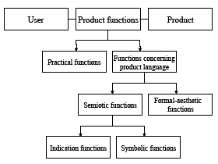
Model of "product language" (Bürdek, 1996;Steffen, 2000).
It must be pointed out, that in the variety of graphic representations, of signs or of the logos, (with the basis of the geometrical surface of shapes), the inertia of the message is altered to a dynamic position – tendency and the logic of originality, which exists until today, is altered. This occurs because the logo – sign itself can self-define its identity in expiration time, because of the change in color of the sign-logo.
[Steffen, Dagmar 2001] researches the possibilities of semiotic projection, that can be given by the designer to the design of a product with the aim :
Α.To create a product to have an increased promotion on its own. (Self promotion).
Β.To state that the product signifies to each culture
Γ.To render the product a direct, dynamic character.
Also, as Ashby claims, many technical capabilities of materials and manufacture technologies correspond in the aspect of the relation between product and material of choice. This is not clearly defined in the product’s significance, but in the commonly accepted existence of technology’s capability and the current capabilities of methods [Ashby 1999].
PRODUCT ABILITY
As [Borjessen K.] points out, the life circle of a product has its present capabilities from the structures and the limits where it is being supported, since the possibilities and the conditions of design are analyzed on this ground. It has been also proved, that product design and manufacture methods have firmly, better results (using approved methodologies and patents) than other, experimental, not commended strategies and methodologies in design.
Professor Desmet, of the Delft University of Technology, in the Netherlands announced the results of his research and classified the answers in five sections, which are: Functional regarding satisfaction, Aesthetic, Social, Emotional-Enchanting, regarding interest. Conclusively, as seen from the above presented studies, a product is defined as a functional and communicative value. The factors of success in product design that prevail, according to these studies, are functional and novel product rendering, its aesthetics, its meaning (such as love for the product, significance of the product for the sole identity of the user as well as the identity of commercial signs) its ergonomics and the price.
Elements that contribute to the product, by influence or without influence, or that even reject it (Gotzsch J.2003). Moreover, Gotzsch [ Gotzsch, J. 2003] describes, in his report in the research project [Τo develop a tool that can be used to define the need for expression in a product at the first stages of product development, during the design specification] The research concluded and has determined three main categories of product expression.
- Expression of product’s personality 2. Expression of the identity of its users 3. Expression of company identity or of trade signs.
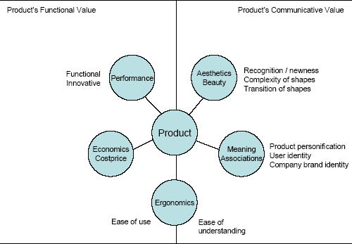
Elements contributing to a product appeal or rejection (Gotzsch J 2003).

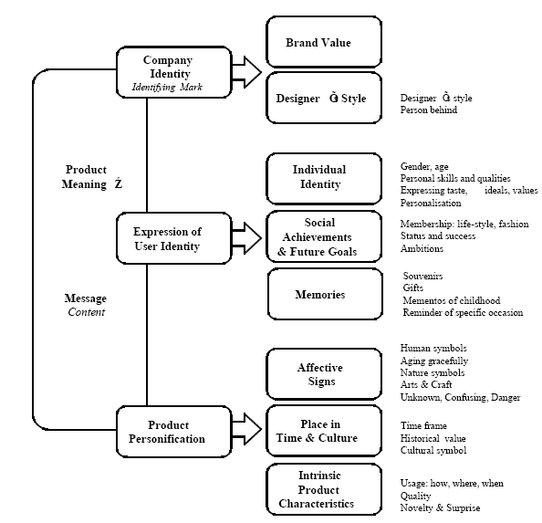

PRINTED ELECTRONICS AND SMART PACKING
In a scientific research, the Frost & Sullivan Company [Frost & Sullivan, 2006] presented the results regarding the trends of printing devices-printers-RFID. Pegged at $10.7 million in 2005, the market for RFID printer-encoders will surge in value to $209.3 million in 2012 for a compounded annual growth rate of 53%. Ιn parallel to the above economic predictions and technological changes, there are parallel relations and influences in the area of crossmedia publishing which is constantly changing in the sector of wireless communications e.g. of mobile telephony and RFID systems.
At present, in almost all European countries mobile telephony has been incorporated in communications in a percentage of about 90 %. This means, the configuration of mobile telephony (mobile phones, technology and services) is the conductive development, which has a priority in research. [Mobile Commerce Dec.2003]. Thus, communication (mobile telephony and other services) will be offered everywhere and every time. Cross media publishing systems have cooperated with this environment of mobile telephony. There are already possibilities for economic transactions in some models, and for the facilitation and management of finance, in a different approach, in a model of Nokia, the NFC Communications/2007,[NFC-RFID].This has as a consequence, an alteration of several actions of the conventional methods and an alteration of fashions, via the use of XML, in electronic communication.[New communication relations/ RFID Journal 2006]. [Howard Taub,2006], vice president and associate director at HP Labs, offered one dollar as a rough estimate of what the chip might cost in volume. That's twenty times more expensive than the volume pricing many are predicting for Gen2 tags in 2008
BACKGROUND RESULTS
FORMATION OF ROLES AND TRENDS/BEHAVIORS
1. The advertiser
The advertiser must organize the setting in the static and the dynamic message from the communication medium, with many transforming capabilities in the relation between the dynamic and the static message. This is defined by the below sections which are proposed from [Stokholm Μ.,2000-2003].
2. Graphic Designer
[ Jesper Clement,2004] defines and describes, that the package must carry information from the producer to the consumer in a large market which functions through competition and in an abundance of products. This means that there exist products in the same category which all have more or less the same quality with other parallel products, that are bought easily, but hard to be distinguished. Therefore, the package must send the message “you buy me” to the consumer, in a situation where the consumer force gives its purchasing interest, in a decision of a few seconds.
The graphic designer must design his pattern in an appropriate way, in order to give all the information through the aesthetic approach, but also through the new behaviour in the digital content.
3. Electronics technician / antenna design/ testing
We know that the antennas for RFID systems have some characteristics which define their operation. The electronics technician will have the constraint and the possibility of cooperation, in the construction of the antenna, with the graphic designer for the fitting of capabilities, on the one side, of the antenna in the space which the graphics surface of the package will permit, but also, on the other side, in order to have the operation that is required by the system and the transmission - reception specifications.
4. Sales
He will be acquainted with the capabilities of the new system and will expand his actions in the electronic commerce [Mobile Commerce Dec.2003]. He will create new sales situation and bring himself into line with respective marketing department in those parameters which influence their department. They will give added value to the product through the products originality. They will increase the reliability of their product though their anti-stealing property.
5. Cost accountant
The character of the cost accountant will redefine the facts of new constant and variable points of data in costs. He will cooperate with all the departments and will arrange the new invoice policy with the salespersons and the cost accounting department. Moreover, he will cooperate with the Technologists, the electronics technicians, IT stuff, Graphic Designers, Suppliers and the collaborating departments and the suppliers with the aim of a safe invoice policy in the relation between productivity and quality.
6. Businessman
It is evident, that the businessman will define new situations and behaviors according to the available technology and culture of society, but also of the global economy state-of-affairs.
7. Costumer-Consumer-User (Characteristics and functions)
Vihma [Vihma 2004] suggests that the qualitative characteristics of the product are represented through its physical characteristic features. In many occasions, the various design characteristics, are, and can be used, to produce these particular relations, so as to infuse the product with an innovative character. We can also speak of drawing “language”, namely drawing as a means of the significance of communication. The connection between character and characteristic features, is the prevailing relationship when it comes to the design of a communication product.
8. Social (Trends Configuration)
Culture and civil – cultural configuration
It is pointed in this report out, that the configuration of culture is not caused by genetic heredity. Furthermore [Γαβριήλ Γ.1995,p.191] proposes encompasses material and spiritual inheritance, of a society, tales and myths, artistic and technical creations, buildings, instruments, legislations and institutions, rituals and customs. However, the fact that renders all these factors constitutive elements of a culture is not their essential being, but rather the meaning that accompanies them.
Researcher, Professor Johanna Drucker [1994] argues in her book, that advertising language forms culture and also that visual language, through its intervention, shapes the culture and the cultural system. Namely, it guides and configures cultural trends. [Ahmed,1998] defines creativity in this frame where “the creativity of organization can be comprehended, as the process where creativity is the introduction to the processes which lead to innovation, competition and to the returns in investment”.
9. Morality – Prestige - Values
Product reliability improvement. This can enhance reliability through information on manufacture data, the technology that has been used, the materials, and all the information for the answering of all questions (information augmentation), the moment act-reconciliation occurs (without any personal contact with the salesperson or the businessman).
10. Legal framework (E.U. – National)
RFID operates in a large array of frequencies, which are not common for all countries. These frequencies are being currently organized in Europe and America in different law frameworks, but they have been grouped in commonly accepted radio-waves of the frequency that is used for the RFID system (IEE, 2005). This fact, will constitute in the beginning stage of the logistics chain, in the applications of electronic, printed materials.
11. Cost (Differentiation in costs, Constant -Variable)
A particularly important sector is the economic one, namely the relations with economic elements and technologies, the production time length, the production line, the periodicity, in the framework of operation of new edition and the relation between productivity-quantity and cost. As [Kleper M.2002/a] reports, the cost will be reduced to a very large degree, when, in mass production, not only circuits and antennas but also screens will be printed. He reports, that the a square inch costs: a. Screen, LCD...1.5 $, b. LED…1$, c. Plasma 1 $ d. Add-Vision 0.15 $ e. Print Media…0.05 $.
12. Consumer – User - Costumer
Communication with the computer system of the product (Knowledge-Information-Indications-Offers….)
Personalization (personalized) of communication with the product, as well as the controlled laid-out environment. Behavior change (Trust-Originality).
Through the direct communication of the system (wireless but also visual contact), through physical presence and his own visual perception the user-customer-consuser will have the possibility of communicating (interacting) with the product and that will have as a consequence, a different relationship between the consumer and the company of the near future, through the change of mentality – usability, but also, through the increase in trust, in knowledge and consumption (NFC).People will use information the moment they need it. This means, that they will use the appropriate crossmedia devices while in parallel social links will be changing, through the new environment of Internet networks and the games they will be playing.
These will have as effect, that young people will be increasingly communicating with each other and that there will be a clear change in society and in communication.
13.Supply Chain - (Propulsion-Storage-Trading-Arrangement)
1. Identifiability behavior through file management 2. Identifiability conditions
3. Identifiability distance 4. Identification Self-definition 5. Counterfeiter system
6. Stock-taking – Store 7. On-demand check
[Roos and Krogh, 1996] claim that the recently established news and communications industry develops a wider range of activities which include the recovery, processing and distribution of information which is implemented by printed matter and electronic means.This has been proved through the application in product packages in the logistics chain, in pioneering companies, but also in large chain stores with cost reduction and many benefits in process acts (time reduction – on-demand check – movement determination – warehouse check etc.).
14. Environment
Sensitivity about the environment from the global community will be of immediate priority in the next years. Accordingly [Philippa Dobson,2006] records and defines the facts that will constitute the basis for the definition of the activity of smart materials, in announcements in LCA (Life Circle Assessment), which has been defined from SETAC ,(Society of Environmental Toxicology and Chemistry) in a managing organization of material from printing industry management. Moreover, she defines activities and methods in relation to the consumption process, the use of materials and their transformation to waste.
CONCLUSIONS
It is clear, that the aim of the improvement of communication and the cultural – enterprising environment framework will have influences from the new models of double communication, (Hybrid print media),as, a conventional optical perception, with digital content.
This will be the case since, design, increase in trust but also new dynamic functions of printed materials, will offer new usability characteristics, which will operate in time and place, in on-demand information, [NFC-RFID, 2007]. A significant alteration will occur to the function of communication, because of the particular presence of digital data in the print – substrate with huge consequences in all sectors.
As a conclusion, since a print work with digital content is a hybrid printed work will be finding itself in a prevailing position versus the conventional one, where it will configure new behaviors, with its double identity, as a communication means of conventional, visual and sound perception, because of the capabilities of the crossmedia.
All these substrates, print media with digital content, (Hybrid print media), will give us, many – many easily uses, and applications functionalities.
FURTHER RESEARCH
1. Classification of elements on an aesthetic basis. Recording of the qualitative characteristics of Printed Electronics.
2. Printing and behavior of the elements in the industrial application.
3. Creation of new business models.
4. To built a new systems for quality controls and new machines, on the sector of production, (printing-press, and post-press, digital systems on T.Q.M..
ACKNOWLEDGMENT
1.[Gotzsch, J. 2003] Managing Product Expression: Identifying Conditions and Methods for the Creation of
.Meaningful Consumer Home Products, Unpublished Doctor of Business Administration Thesis, Brunel
University, Henley Management College.
2. [Nomikos et al,2006] Towards a conceptual framework for the design of intelligent packaging services in print and cross-media: the role of decision support systems. Conf.in Printing Technologies / SPb 06 / 26-30/6/2006 – ST. Petersburg - STATE UNIVERSITY of TECHNOLOGY and DESIGN. Intern. Proceedings, p.p.22.
3.[Johanna Drucker 1994],The Visible Word, University of Chicago Press/pp193 / 1994.
4.[IDTechEX,2005],International Conference Europe, Printed Electronics, Master Class 1/p.p.12,Facoulty of Law/19-20/2005,Cambridge,U.K.
5.[Leslie Oak,2004],Print 2020,From Pulp to Pixel,RIT/2004/Leslie Oak,Editor- in-Chief,pp.9.
6.[NFC/RFID] Toronto, ON, Canada – January 30, 2007 – Sirit Inc. (“Sirit”) (TSX: SI), Leading provider of Near Field Communication (“NFC”) and radio frequency identification (“RFID”)/Mobile Tel.
7.[Politis,Α.2001],Customdp, 2001,Royal Institute of Technology [KTH], Stockholm Sweden./Τhe influence of the human factors on the performance of media enterprise and case studies on cross – media publishing in Greek media enterprises»
8.[Nomikos et al,2005], Exploring cross-media concepts for future packaging – Challenges for the printing industry/ Spyridon Nomikos, Anastasios E. Politis, Jenny Darzentas, Thomas Spyrou, John Darzentas,Proceedings,32nd inter. Conf.Iarigai.4-7 sept 2005, Digitalisation and print media p.p.317-319
9.[MIT Auto-Id Labs],6-8 April 2004,Presentations
10.[Politis, A.,2004] 2004, Human capital development and competence structures in changing media production environments” Doctoral Thesis, Royal Institute of Technology, Stockholm Sweden.
11.[Karjalainen 2004, 213].KARJALAINEN, Toni-Matti 2004. Proceedings in Semantic Transformation in Design. Communicating strategic brand identity through product design references, pp.213. Helsinki: University of Art and Design Helsinki.
12.[Vihma 2004],VIHMA, SUSANN (ed.) Oct/2004. Semantic & Aesthetic Functions in Design. Report of the workshop and three papers from the 2nd Nordcode Seminar. Working Papers F28. Helsinki: University of Art and Design Helsinki.
13.[Kallenbach J./2004][Syntactic system-Semantic System, Kallenbach J.,2/May/2004,Master Thesis,Multimedia Publishing ].
14.[Johanna Drucker 2001], University of Columbia- Visible Word-The University of Chicago Press,/ Every Medium has a Material]pp 68.
15.[Nils Enlund/KTH-Mattsson Bertil/STFI-Robert Picard /KTH-Borje Alstrom/Den-Gulliksson/Finnland),[T2Fs Project,STFI/2001
16.[Karjalainen 2004, 213].KARJALAINEN, Toni-Matti 2004. Proceedings in Semantic Transformation in Design. Communicating strategic brand identity through product design references, pp.213. Helsinki: University of Art and Design Helsinki.
17.[Johanna Drucker 2001], University of Columbia- Visible Word-The University of Chicago Press,/ Every Medium has a Material]pp 68.
18.[Steffen Dagmar, 2000] (ed.): Design als Produktsprache. Der ”Offenbacher Ansatz” in Theorie und Praxis. Verlag form theorie, Frankfurt am Main, 2000.
19. [Handbook of editor, 1998]-Το εγχειρίδιο του έκδοτη 1998, Σύλλογος εκδοτών βιβλιοπωλών, Αθηνών 1998,σελ.1-17. [in GREEK]
20.[Roos and Krogh, 1996]: Roos Johan & Krogh von Georg: «Managing Strategy
Processes in Emergent Industries – The case of Media Firms»Macmillan Press Ltd, London, UK, 1996
21.[Sabelstrom K.2001],The Multimedia News Reporter:Technologies and work processes.The 2000 TAGA Proceedings.TAGA Office,Rochester,New York, USA,pp53-66.
22.[Neuman 1991],The media Gap/ [Marko Turpeinen Phd,25-2-2000,Helsinki University of technology-Espoo-Finland]pp.2.
23.[Kleper M.2002],Prof.Michael Kleper,The Generation Beyond Print-on-Paper,RIT/Sept.2002/Monograph/pp 15.
24.[Ivana Ziljak, 2003], Univ. Zagreb, Faculty of Graphic Arts -Zagreb, Croatia. The collapse of the fundamental principles of printing, Iarigai, Advances in printing science and technology : proc./30th International Iarigai Research Conf., Cavtat – Dubrovnik 2003. ISBN: 953962766-4 / Designing and customising new screening elements for digital printing technologies – Tools for graphic designers.
25.[Frost & Sullivan,2006],Major Growth Ahead for RFID Printer Market/11/ Dec./2006]
26.[Howard Taub,2006], Cost /Gen2/HP.RFID World/Journal-19/7/2006
27.[RFID Journal 2006]-New relations ships on communications,RFID World/Journal-19/7/2006]
28.[PhilippaDobson]. www.pira.co.uk/admin/_private/TechnicalArticles/ Dobson P. LCA Applied to the printing Industry,PIRA International
29.[Dreyer, R., 2001]«Cross-Media-Publishing erfordet eine integrierte Produktion”, article published at t Deutscher
30.[IDTechEX,2005] 19-20/April/2005 Cambridge-Presentation, Harrop Peter-.[Operations in Smart Packaging.]
31.[Stokholm, M.],(2003) En model for Integrated design, Aalborg: Architecture & Design Publications. Case studies used in the present article by Marianne Stokholm (2003).
32. [Borjessen K] PhD programme, University of the Arts London, 2004.
33.[Γαβριήλ Γ.1995,p.191],Τεχνολογία και Παραστατική σκέψη/Δράση και Σύστημα/Ιωάννα Τσιβάκου -Σύγχρονες Προσεγγίσεις στην Θεωρεία των Οργανώσεων/σελ.191/.εκδ.Θεμέλιο [in GREEK]
34.[Mobile Commerce Dec.2003].Ηλεκτρονικό εμπόριο και κινητή τηλεφωνία 2003/Project EU/2003.
35.[Jesper Clement 2004],In Communication and aesthetic as a part of packaging design,Helsinski,2004.
36.[Worsley P./1970] Worsley, P.(1970),Indroducing Sociology,Penguin,Harmondsworth,pp.24.
37.[Borjessen K.]. Borjessen K. PhD Thesis /University of the Arts London, 2004.
38.[Politis, A.,2004-a] 2004, Human capital development and competence structures in changing media production environments” Doctoral Thesis, Royal Institute of Technology, Stockholm Sweden.

